**Operating System Lab**

**Laboratory Exercise #1**



**Session: 2021**

**Submitted by:**

**Wali Muhammad 2021-SE-39**

**Submitted to:**

**Mr. Waqas Ali**

Department of Computer Science, New Campus **University of Engineering and Technology Lahore, Pakistan**

**Linux (Ubuntu) Installation**

Installing Ubuntu using virtualization tool named VMware Workstation Player.

**What is VMware Player?**

VMware Player is a general-purpose virtualization tool for x86 and x86-64 hardware, targeted at server, desktop, and embedded use, that allows users and administrators to easily run multiple Operating System in one Machine.

**Steps Involving in Installation are:**

1. Download & Install VMware Workstation 16 Player.
2. Download Ubuntu 22.04 LTS.
3. Install Ubuntu with VMware Workstation 16 Player.

**VMware Player**

* **Home Screen**

After installing the VMware Workstation 16 Player, the software is opened and the Home Screen is shown below:

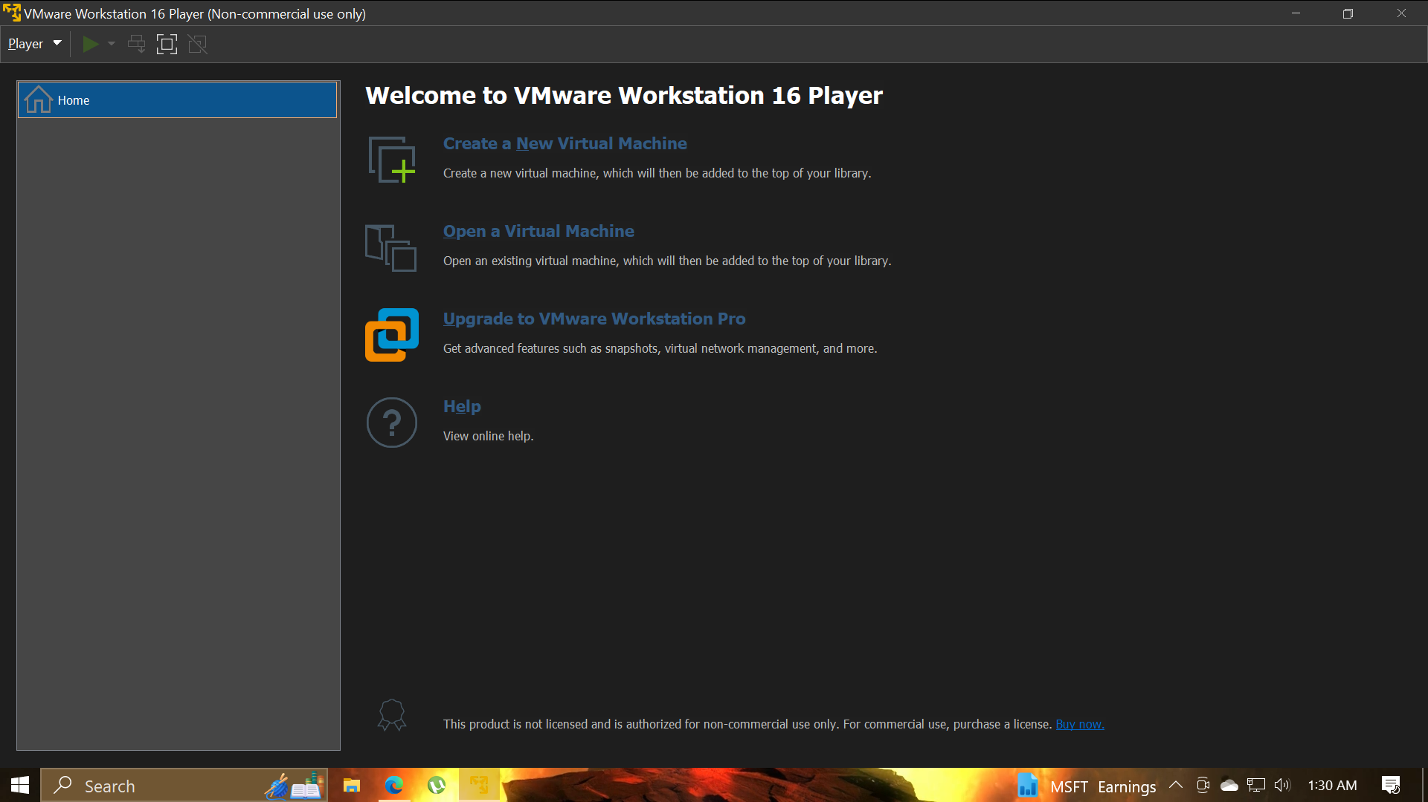

**Task #1**

Install Ubuntu using virtualization tool named VMware Player.

* **Creating a Virtual Machine**

**Steps followed are shown below:**

To get started, Click on “New” option.



A window will open and it look like this. 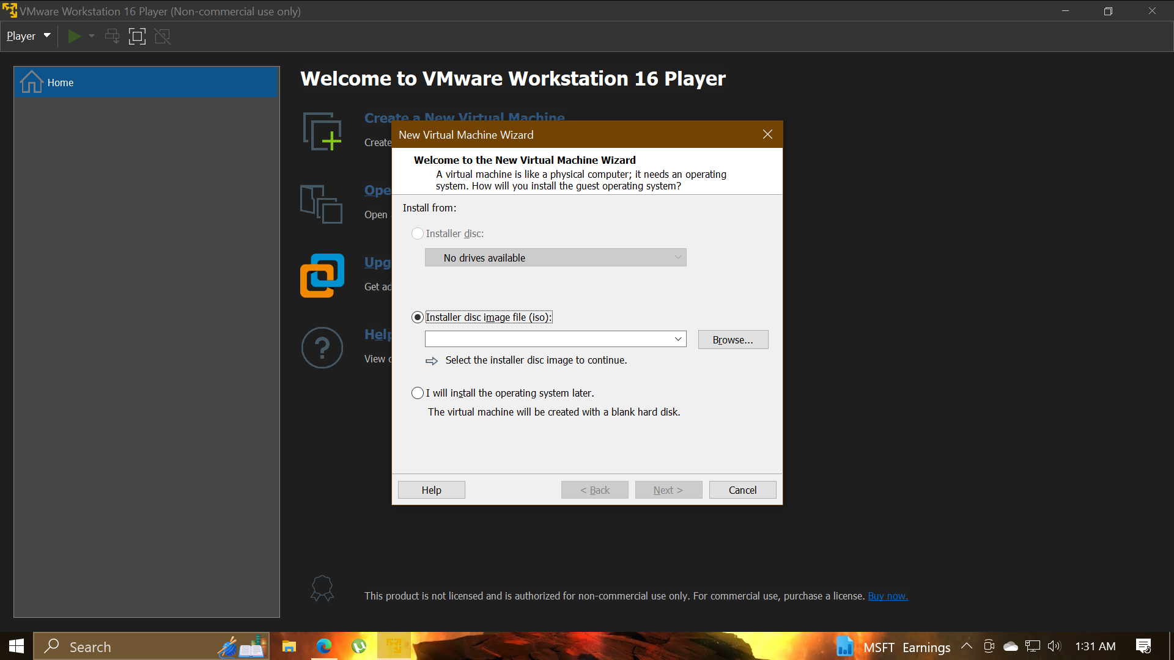

Select the ubuntu 22.04 LTS ISO Image. 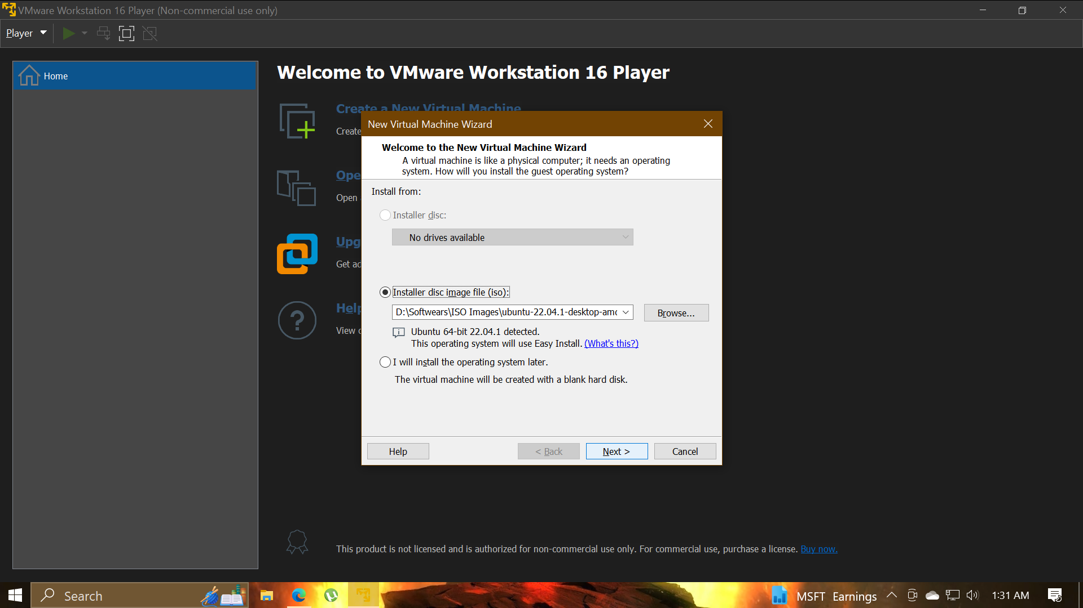

Enter the required data in Fields. Click on “Next”.  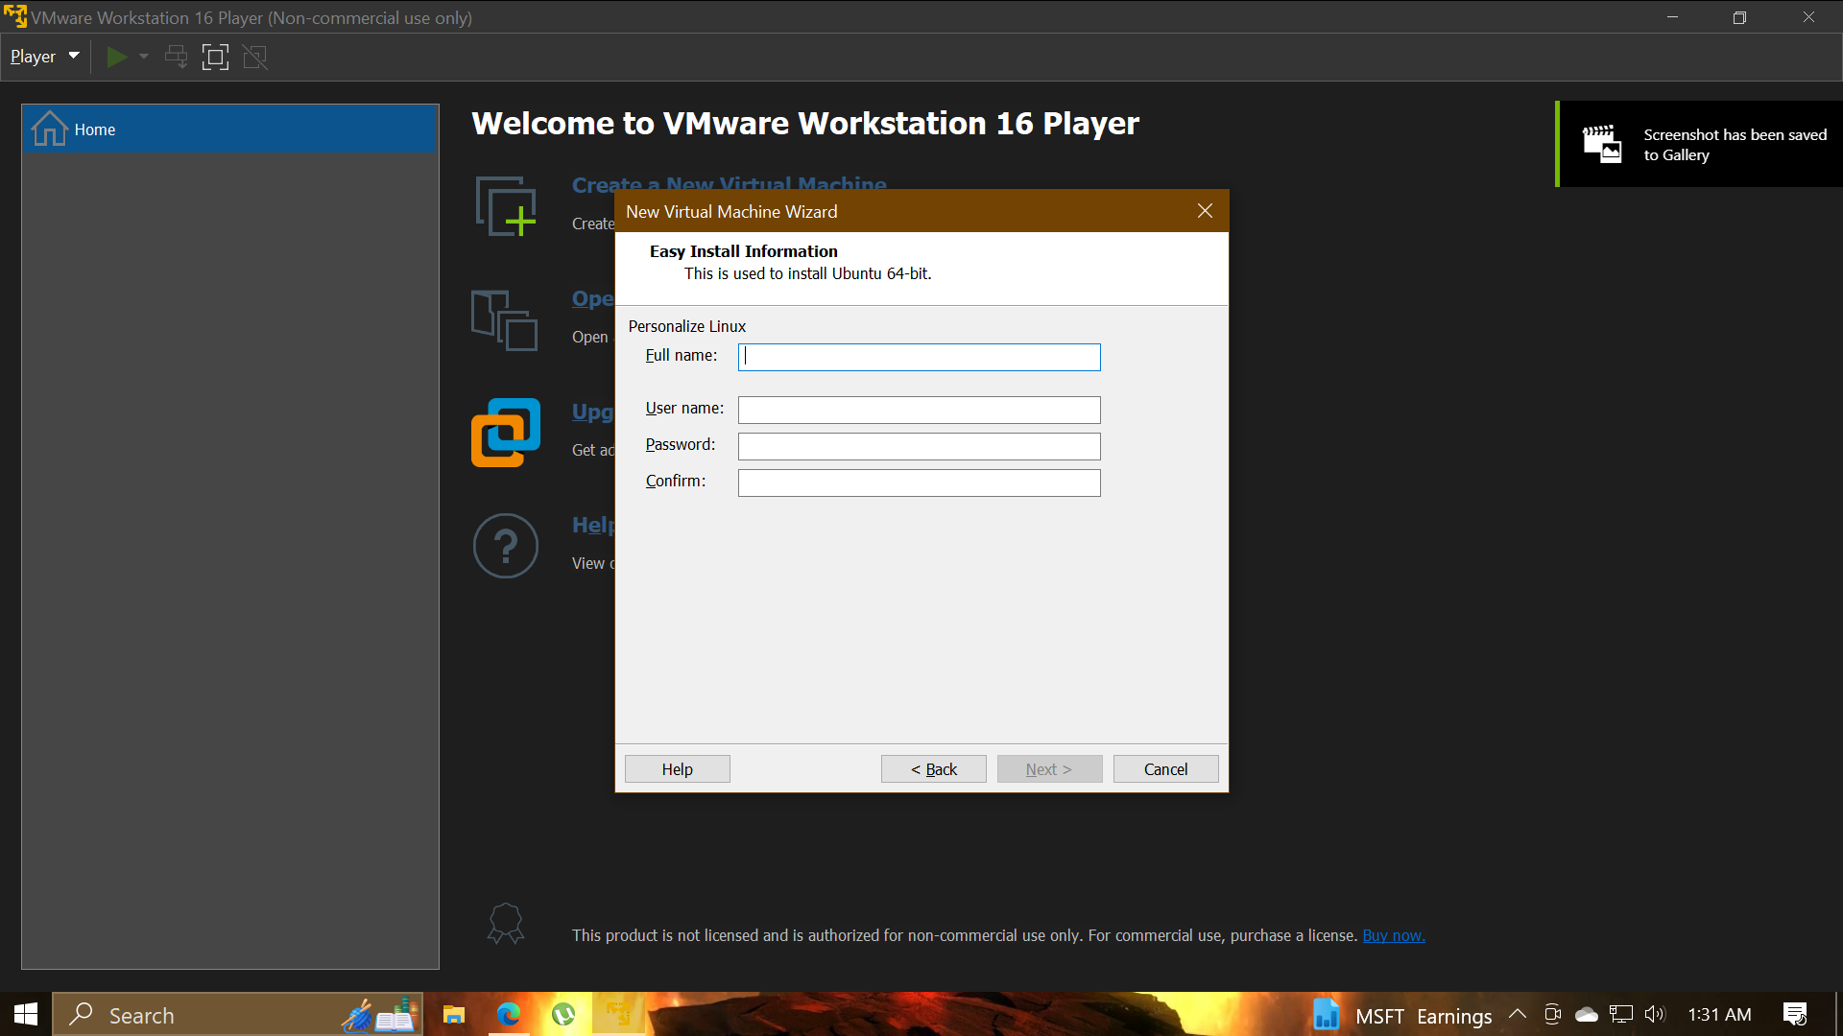 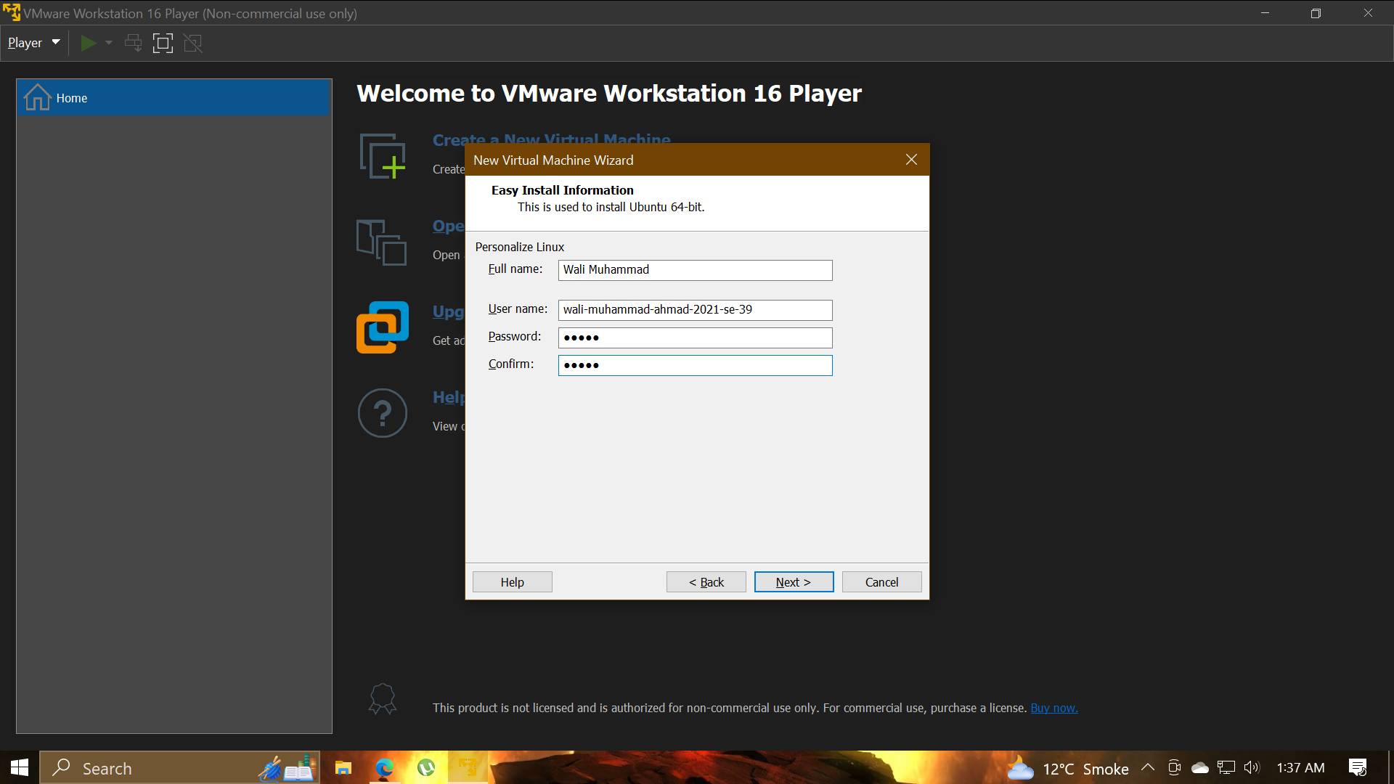

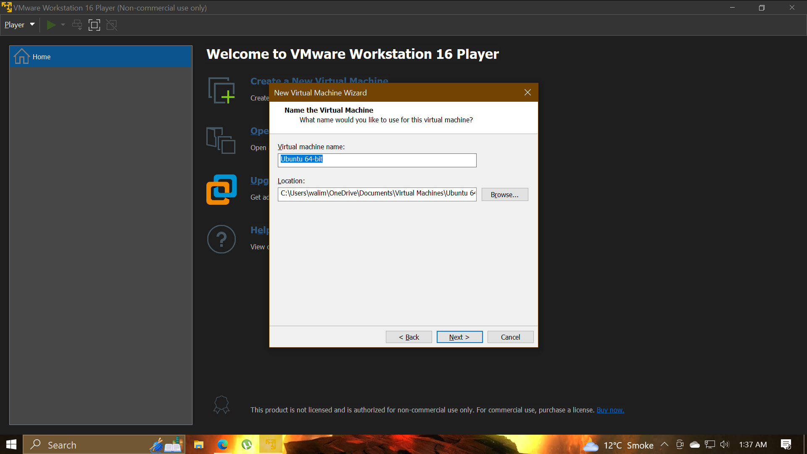

Select Base Memory and Processors amount to allocate to Virtual Machine. Then Click on “Next”.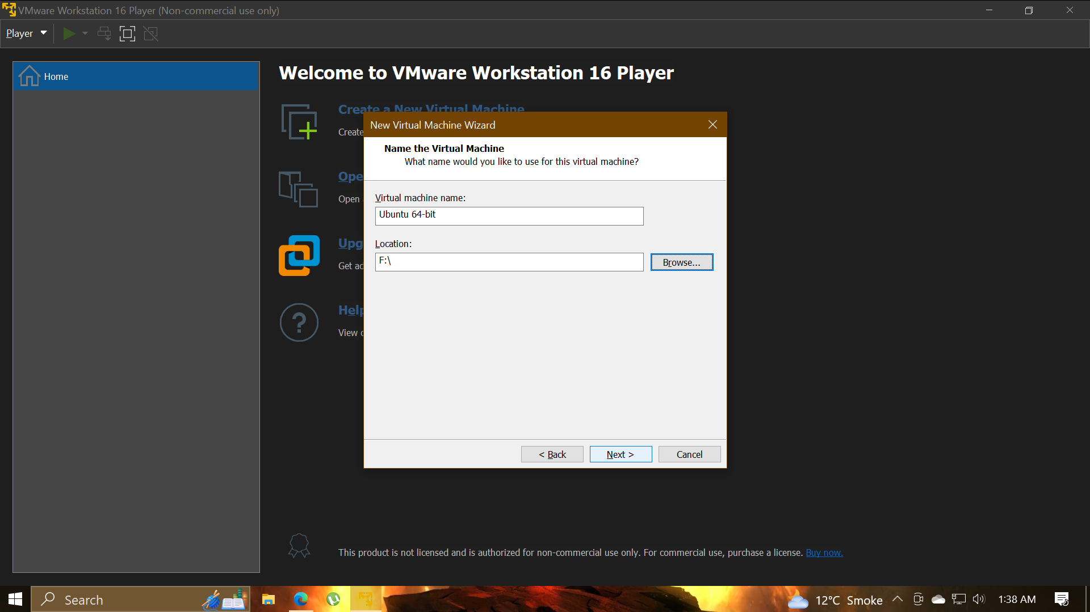

Select storage amount for Virtual Machine. Then Click on “Next”. 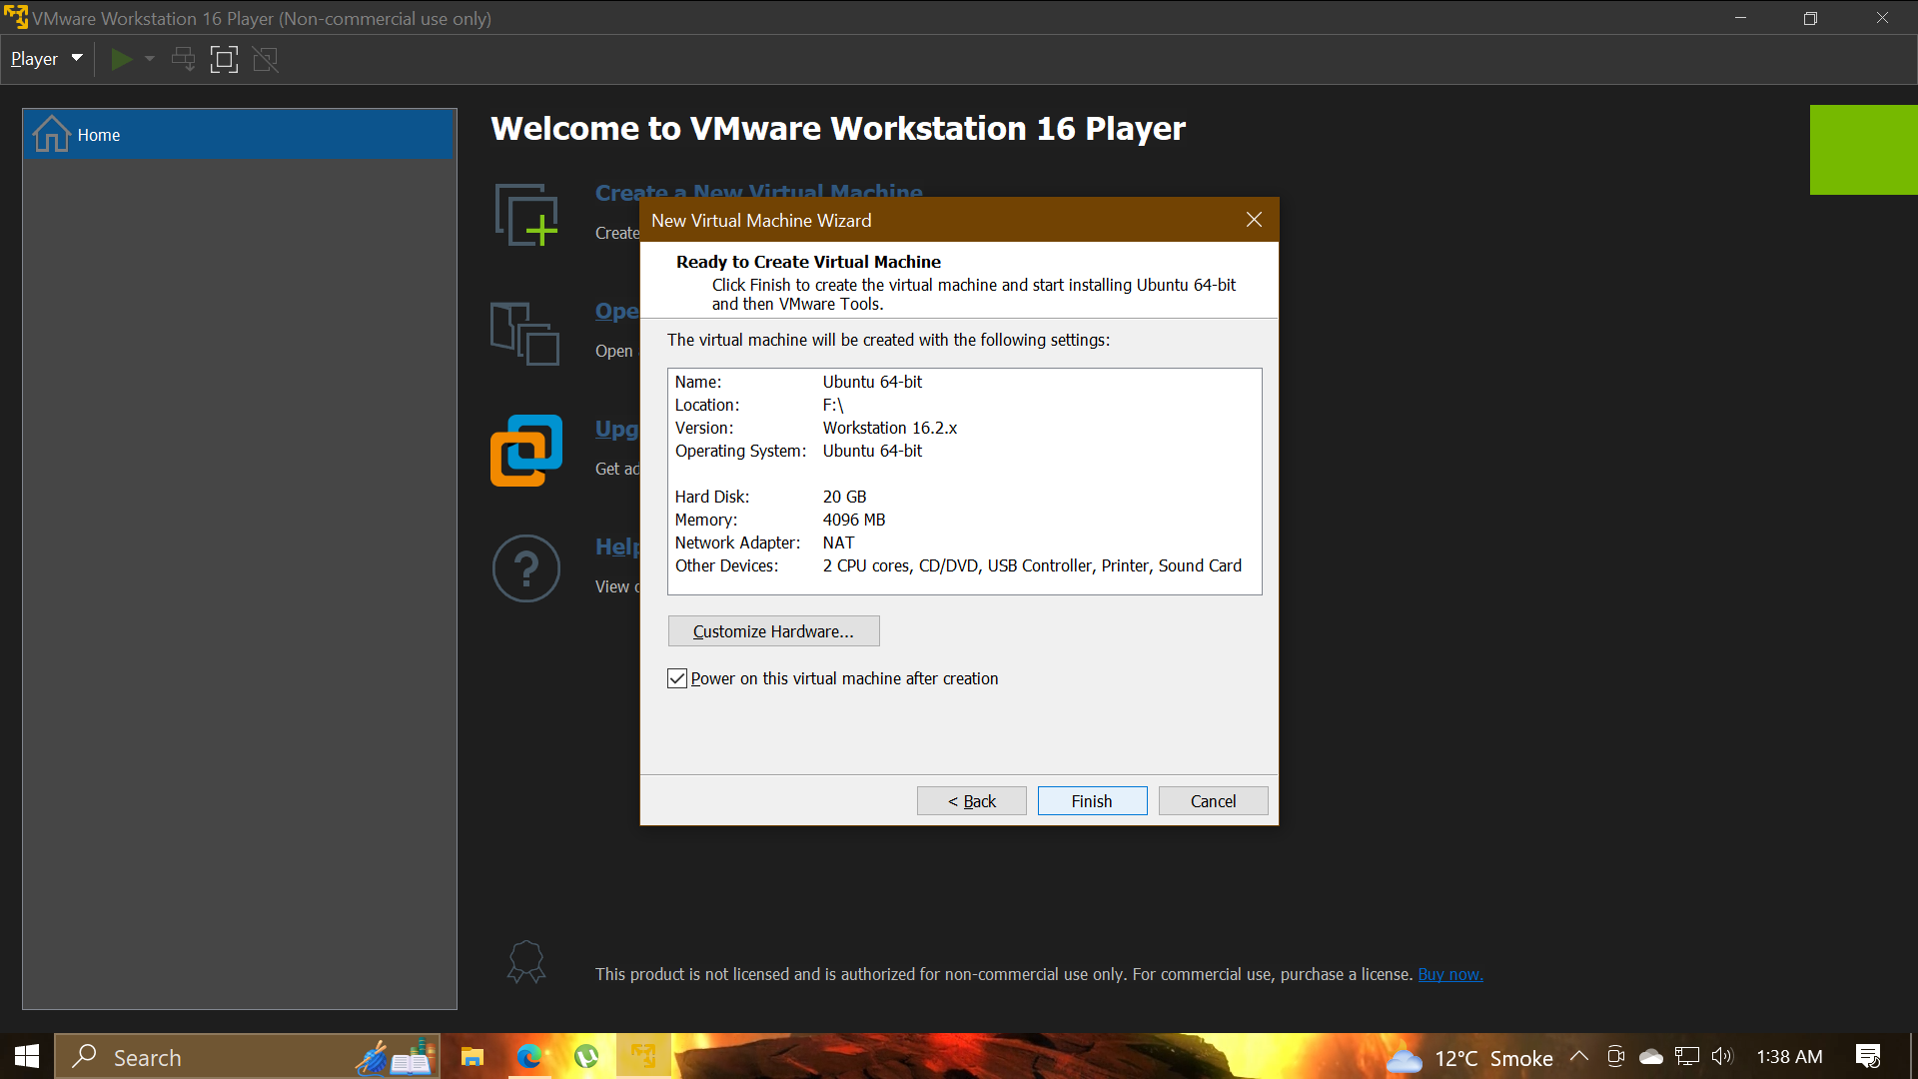

* **Installation of Ubuntu**

**Steps followed are shown below:**

It automatically starts installing.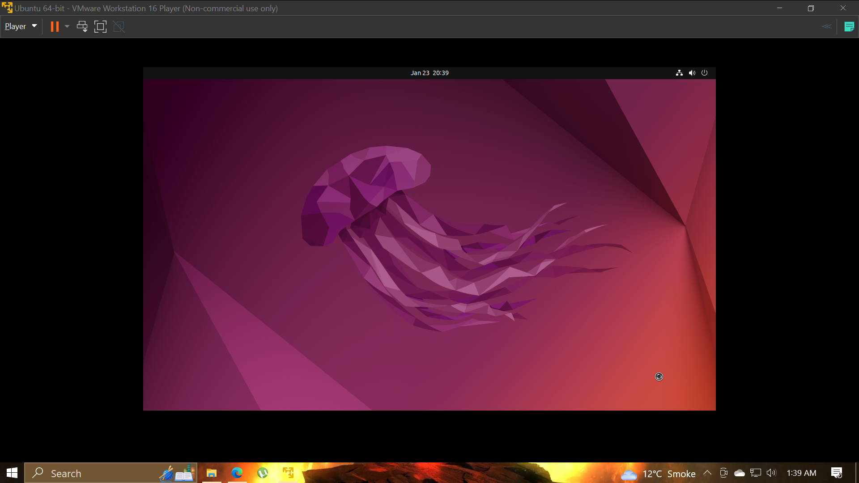

My PC run into a Problem shown below.

* **Fixing Issue**

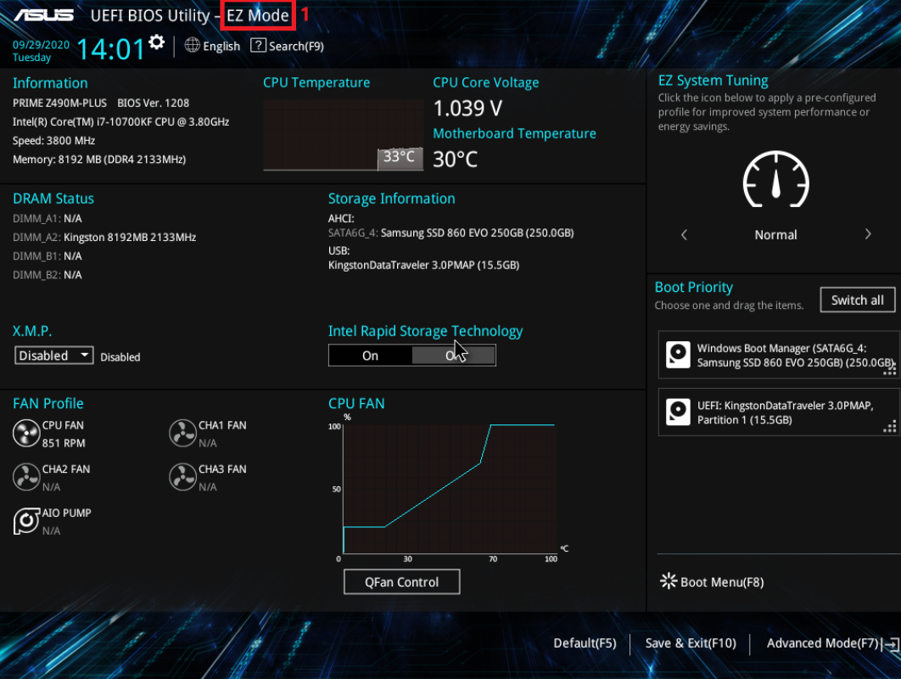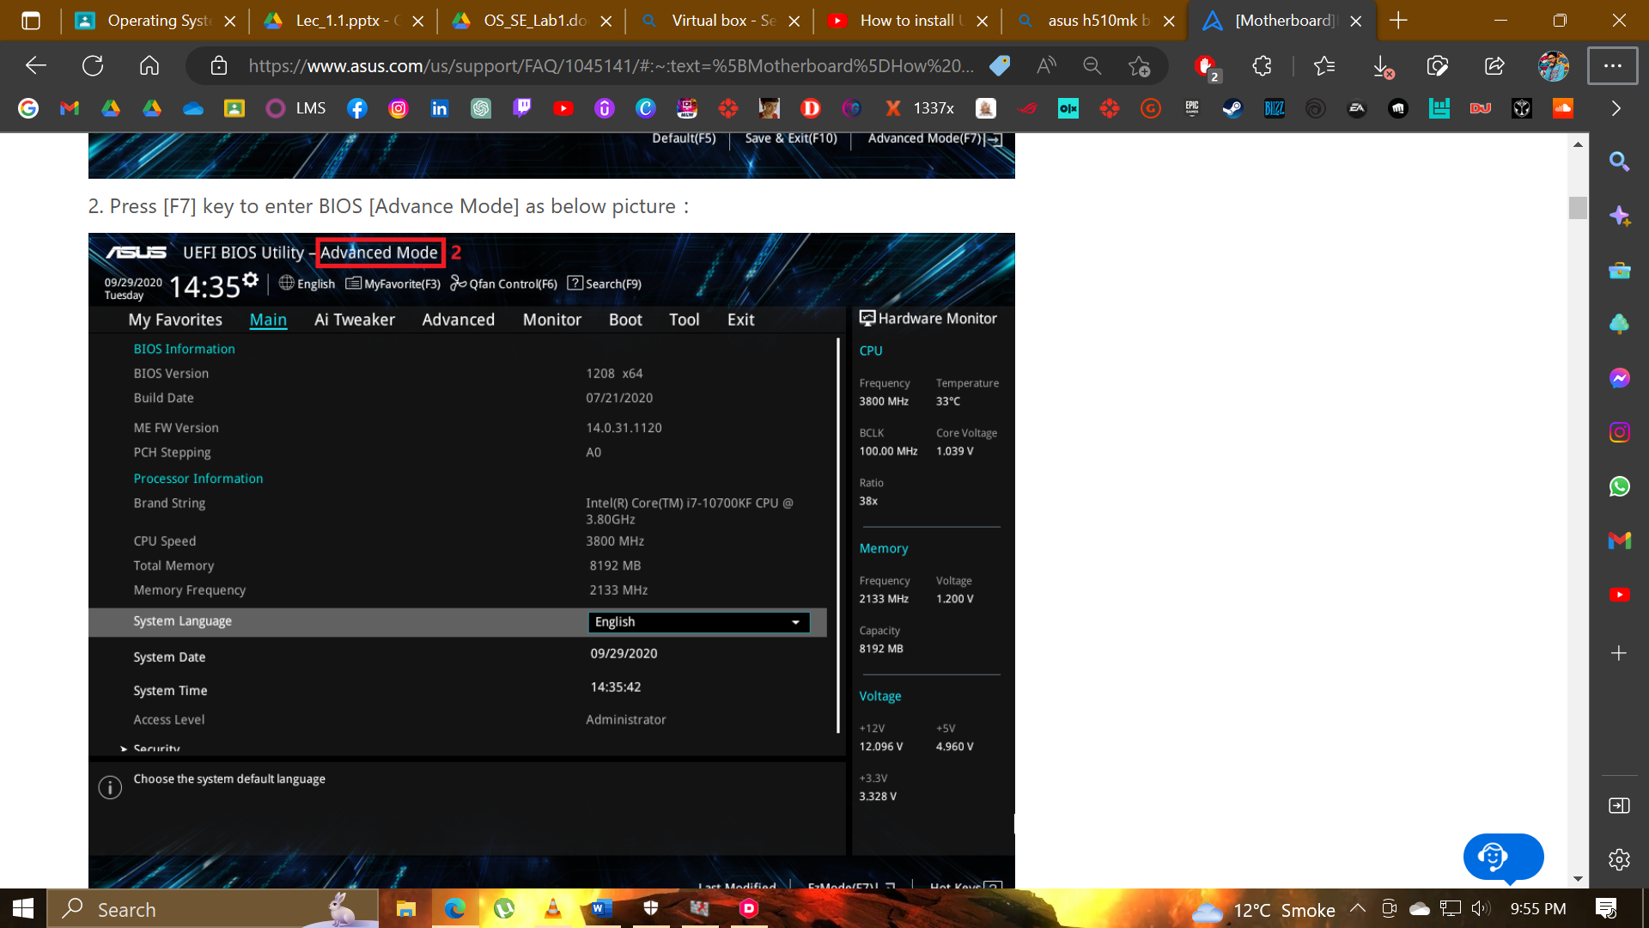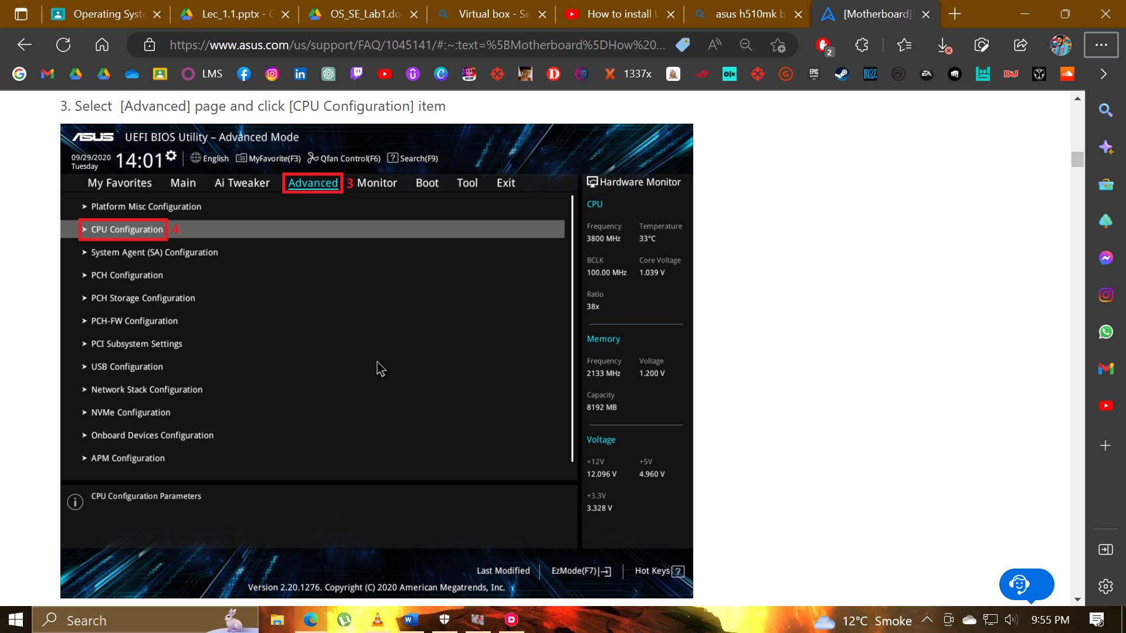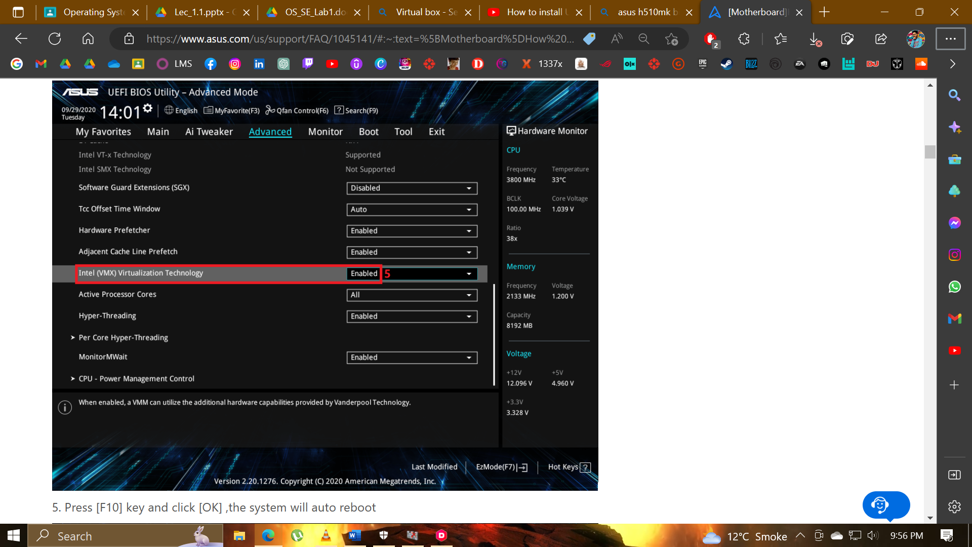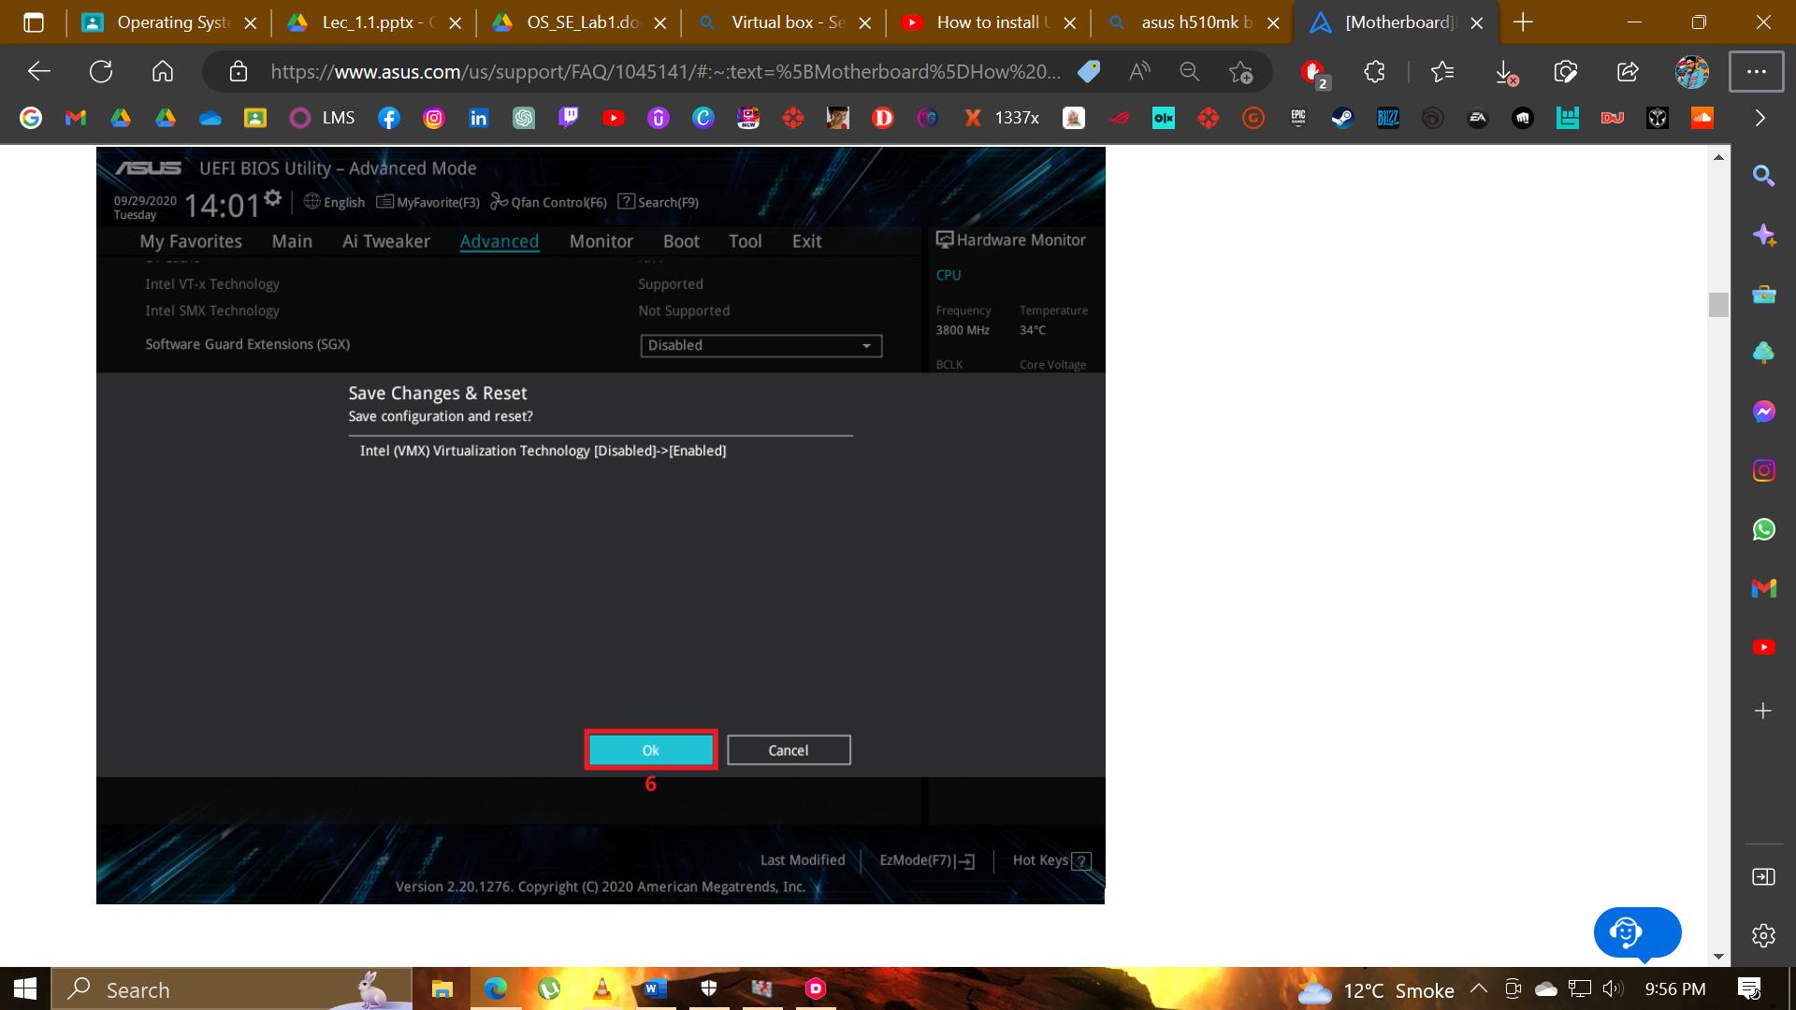

* **Installation after fixing issue**

**Steps followed are shown below:**

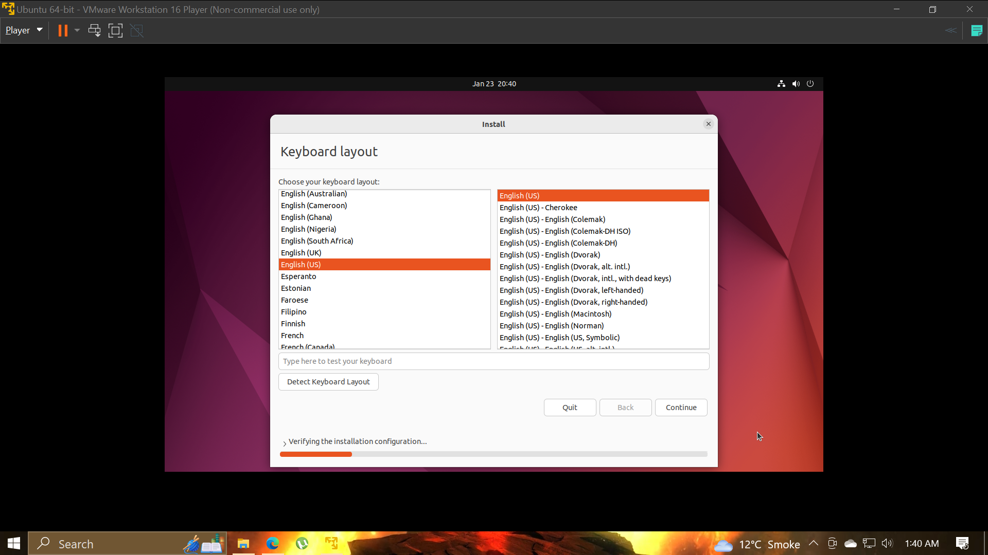

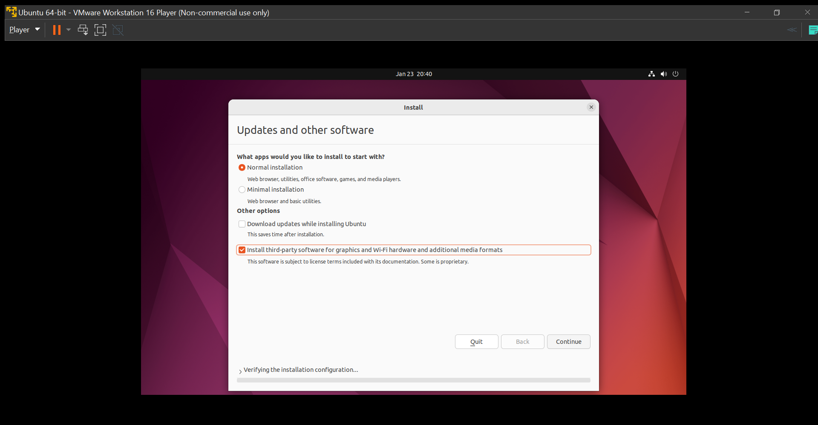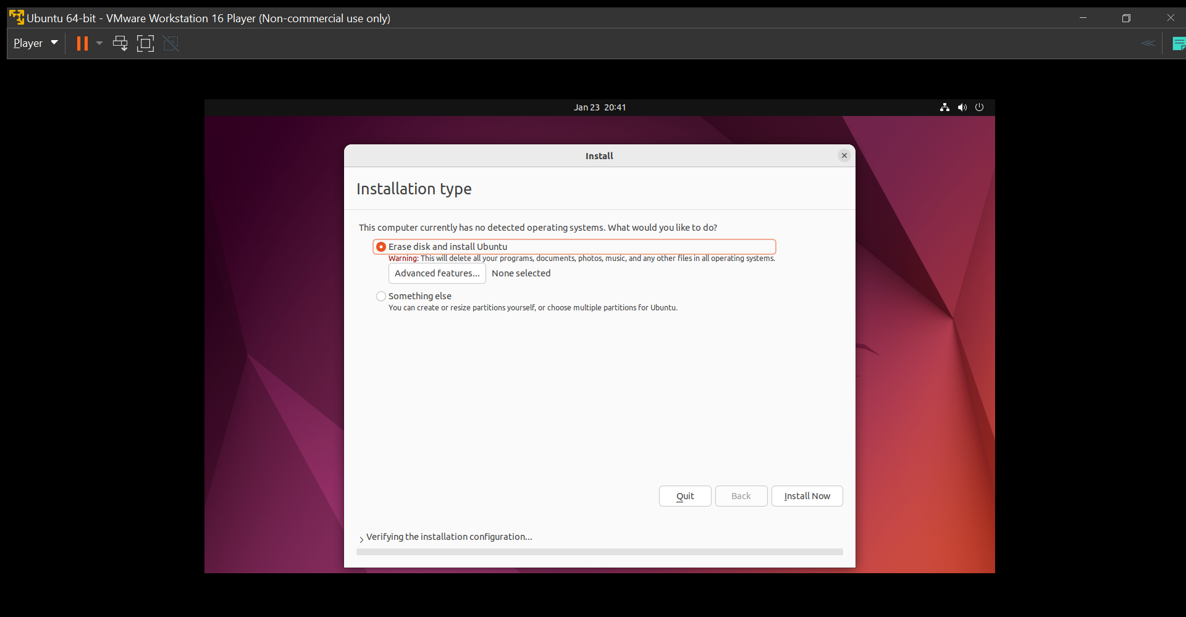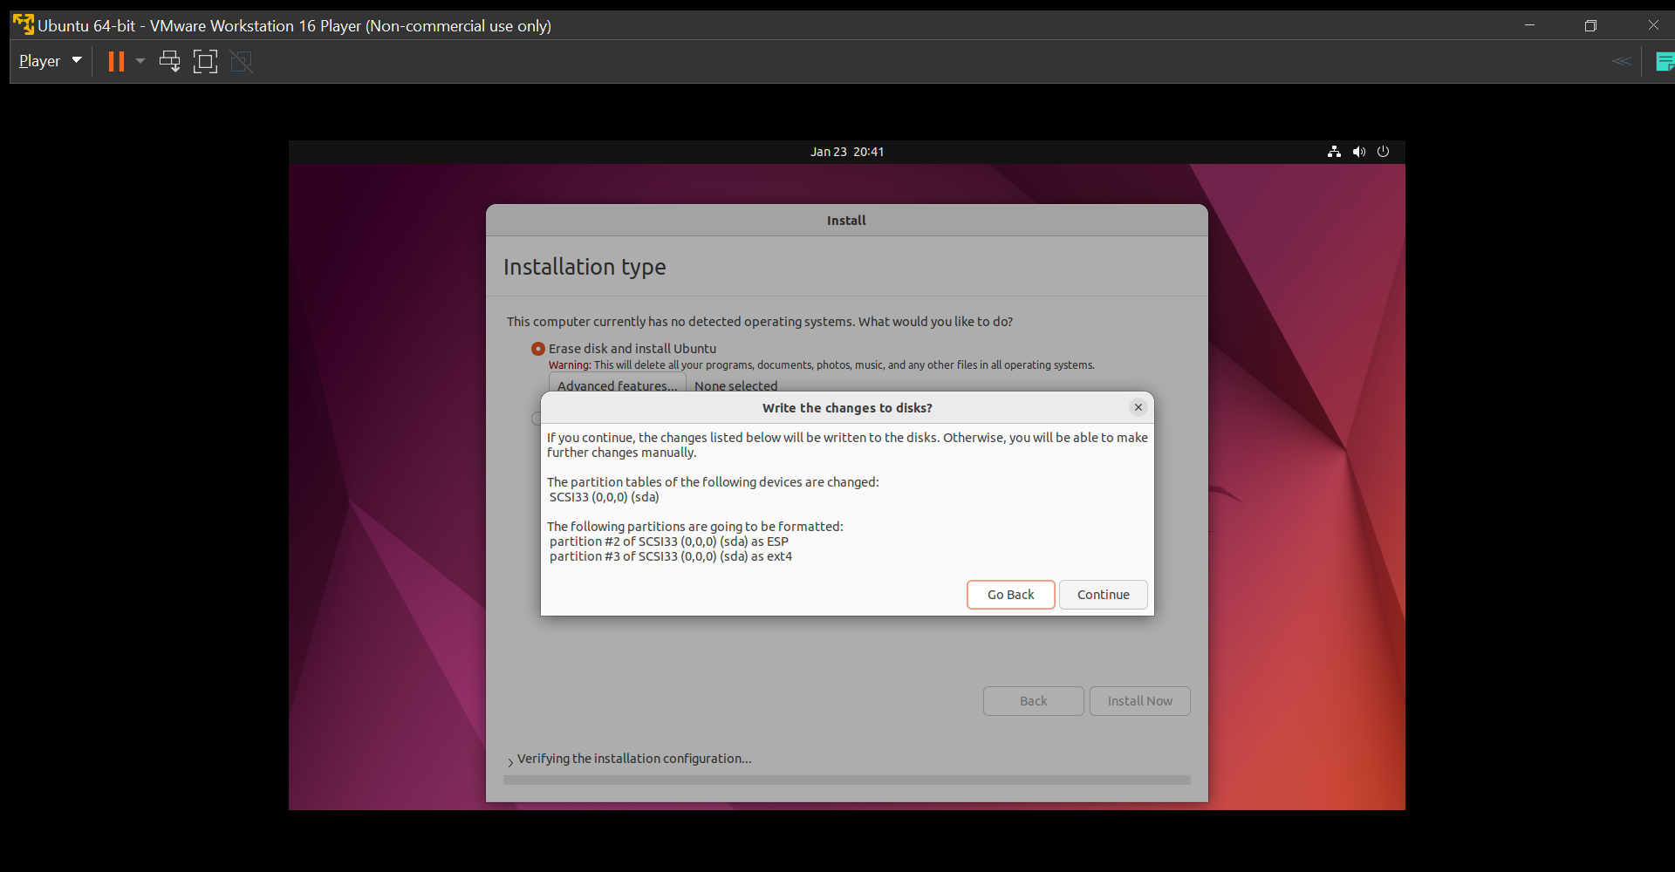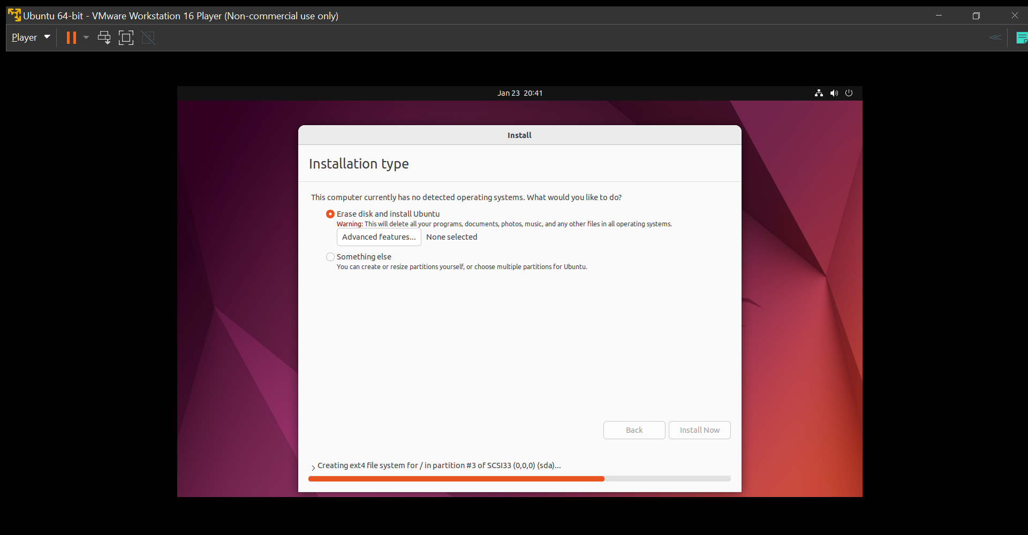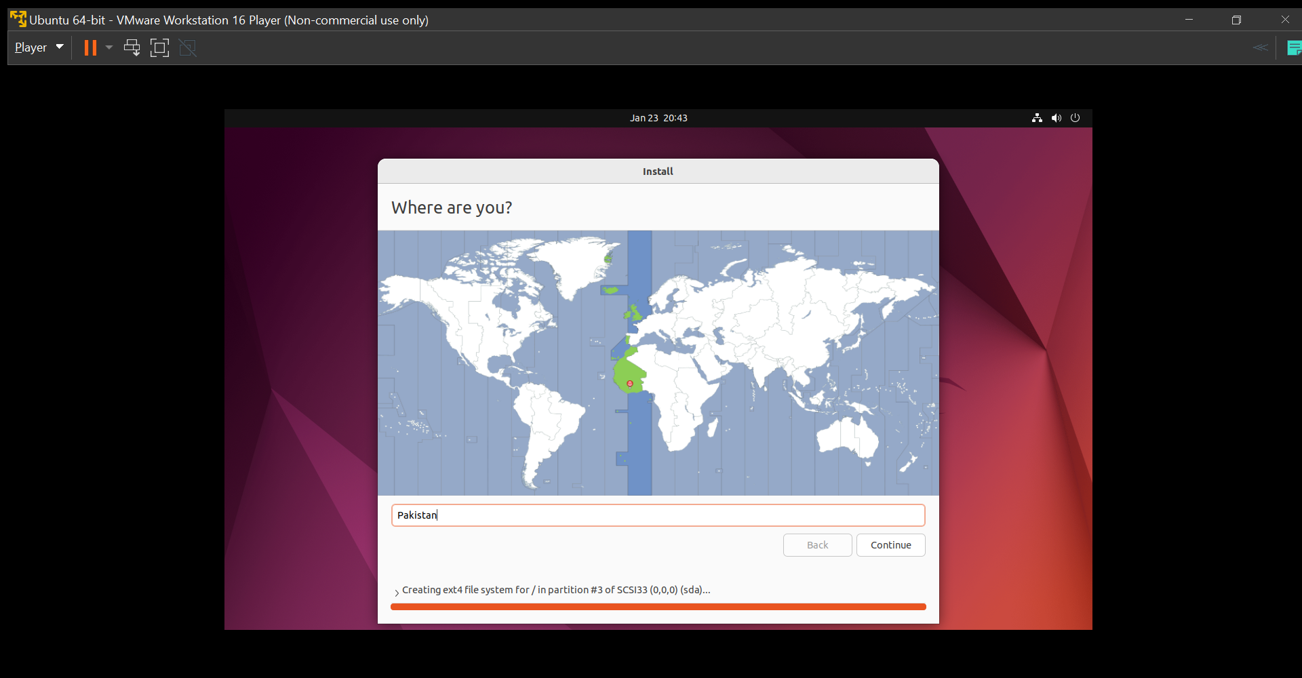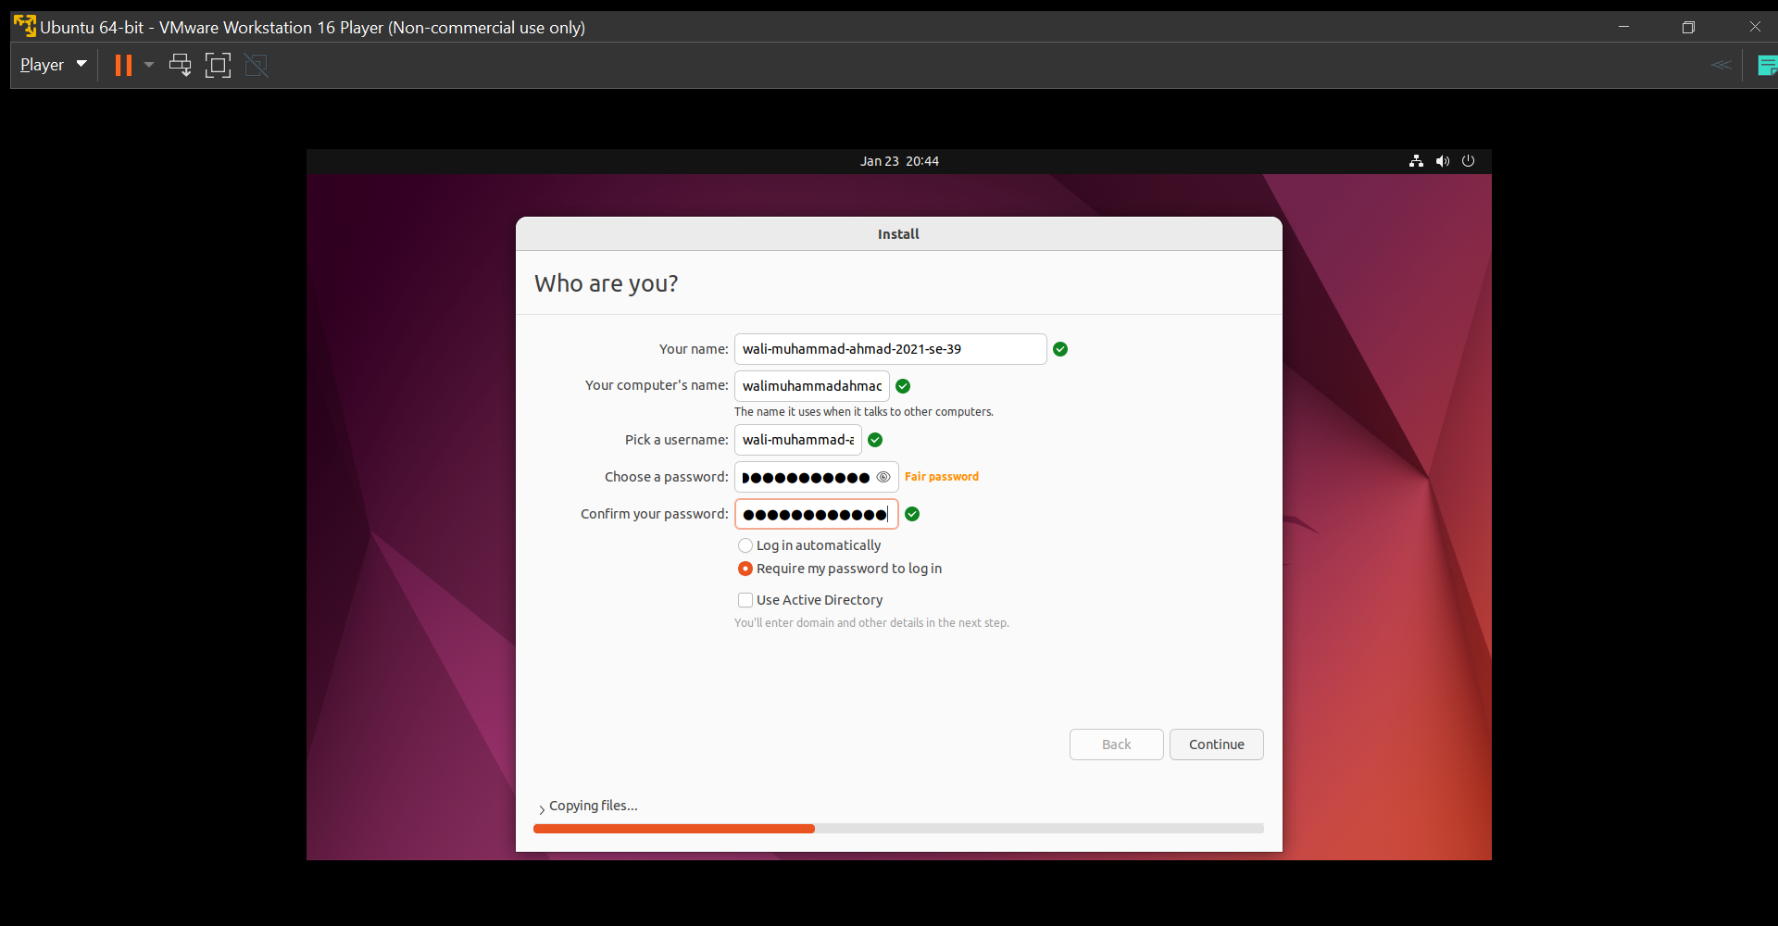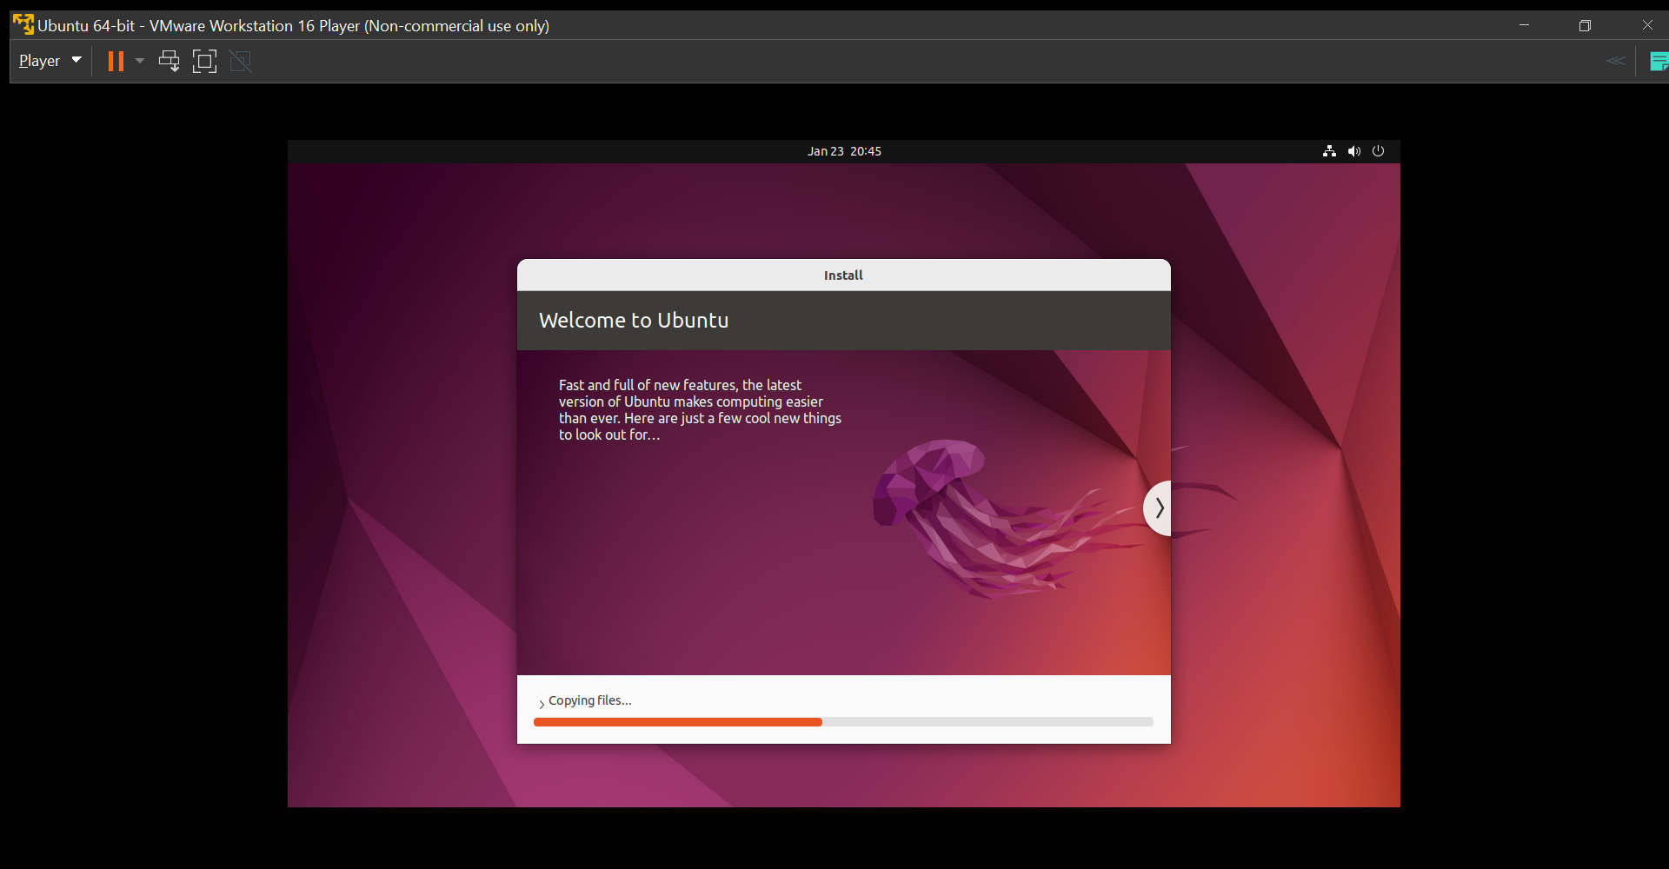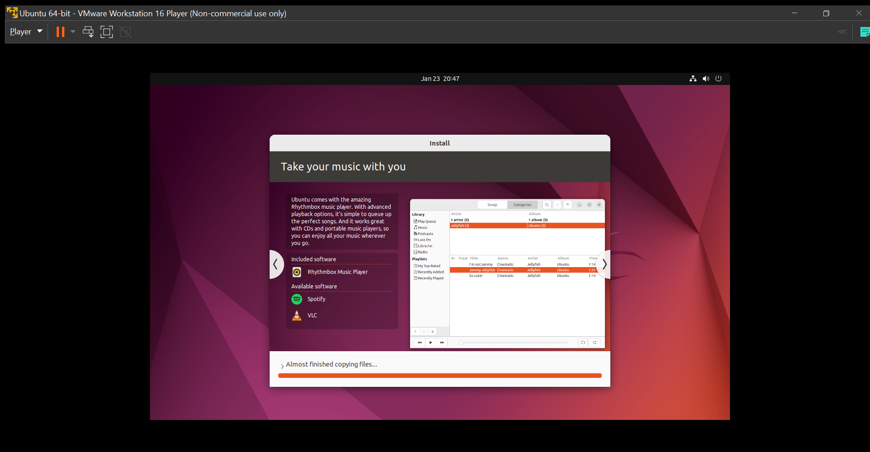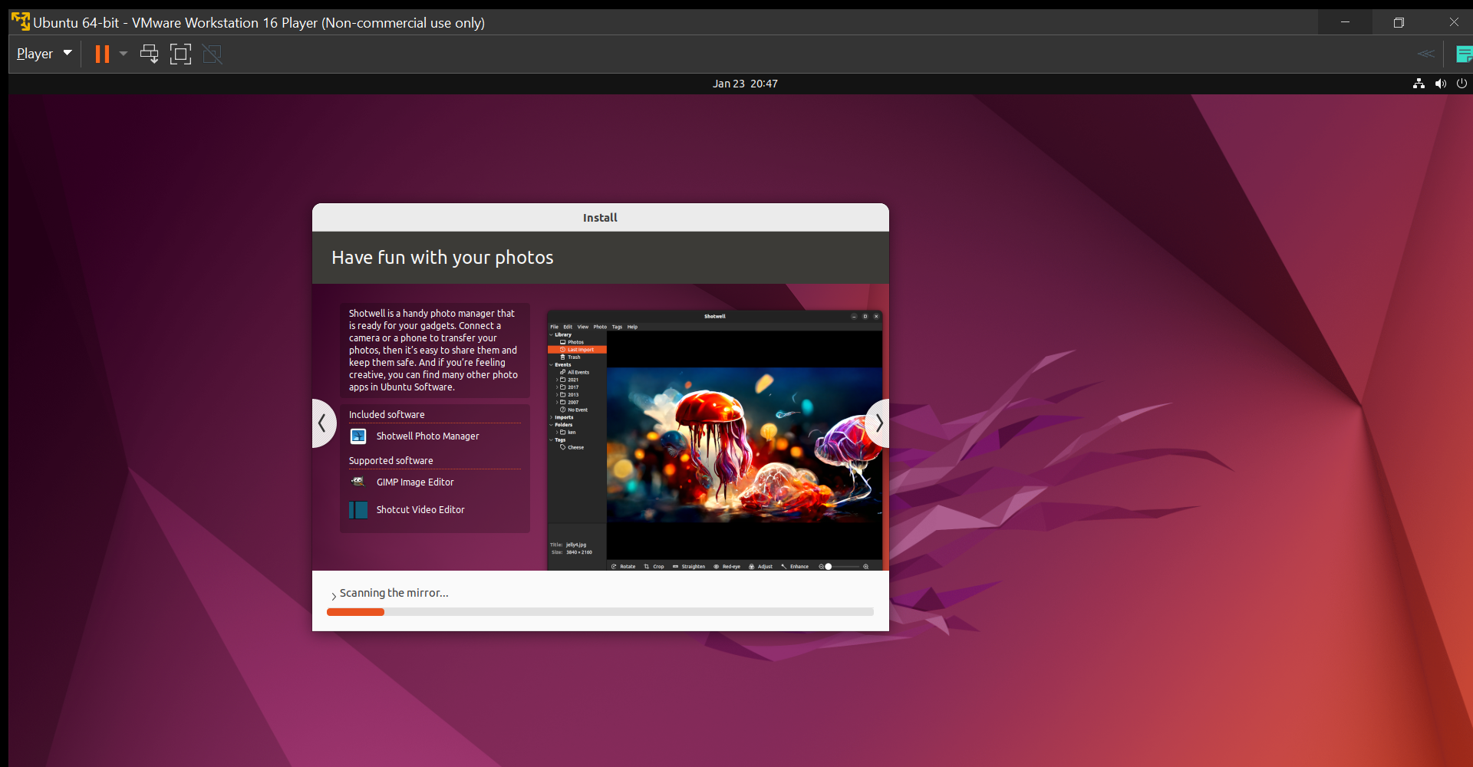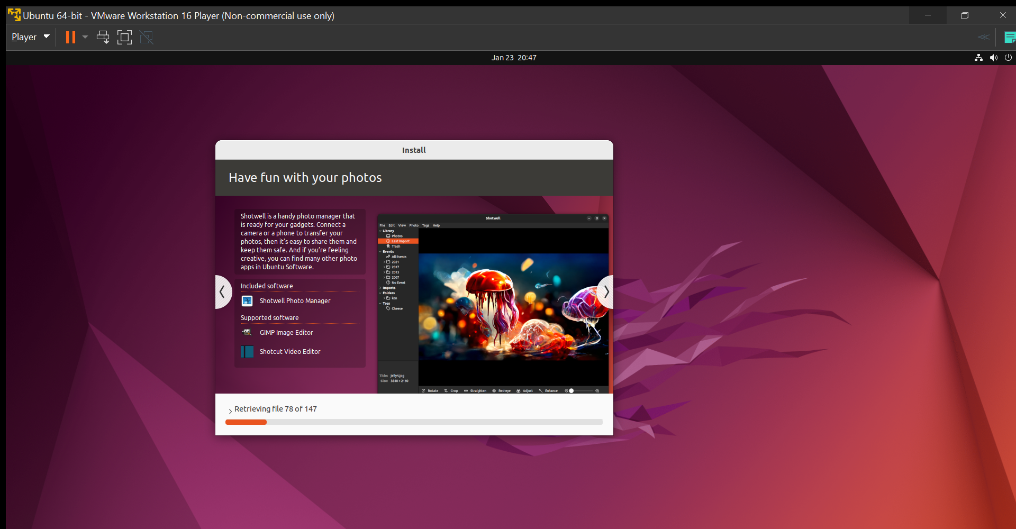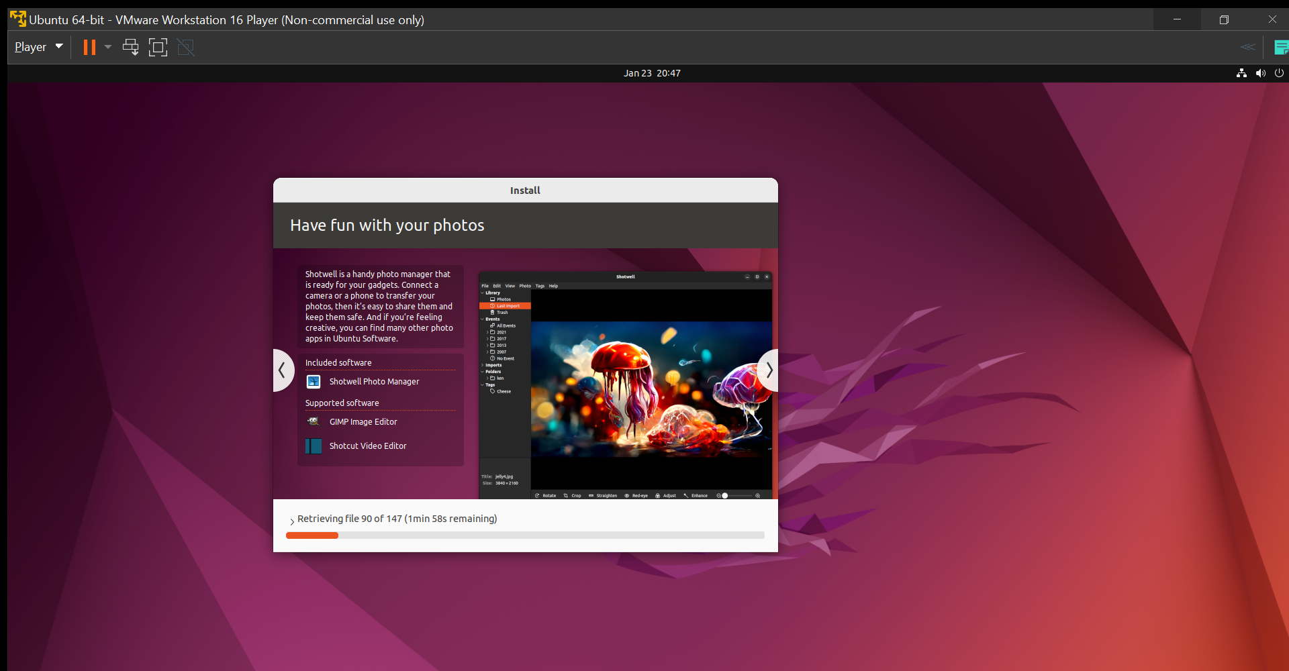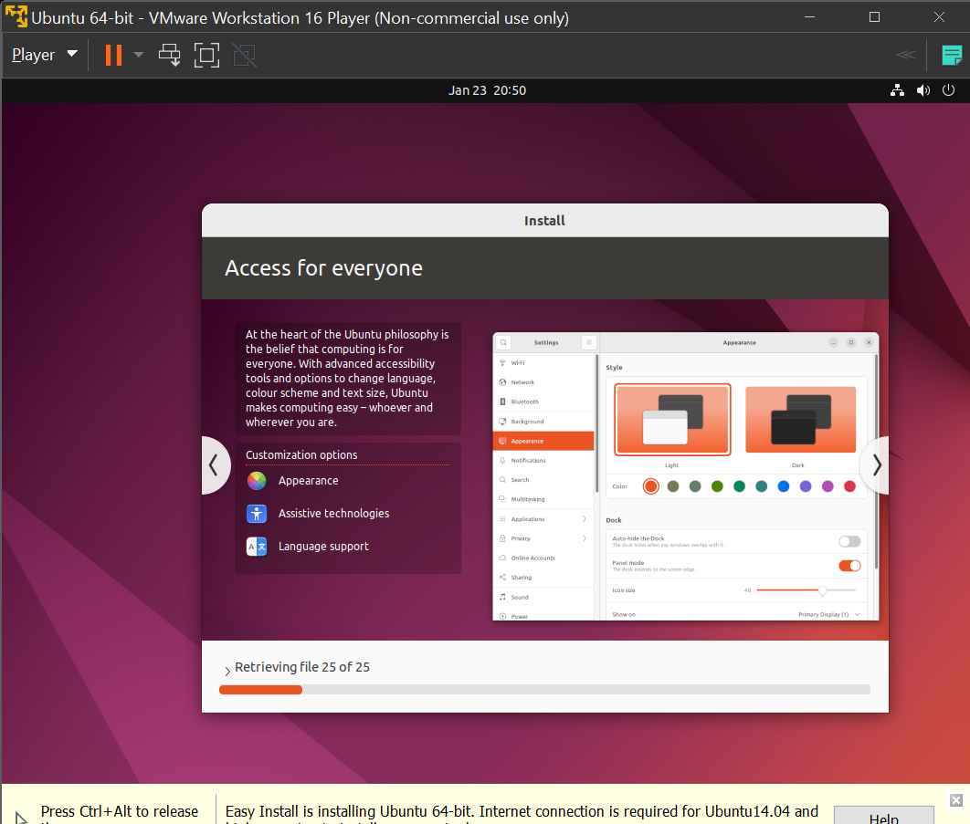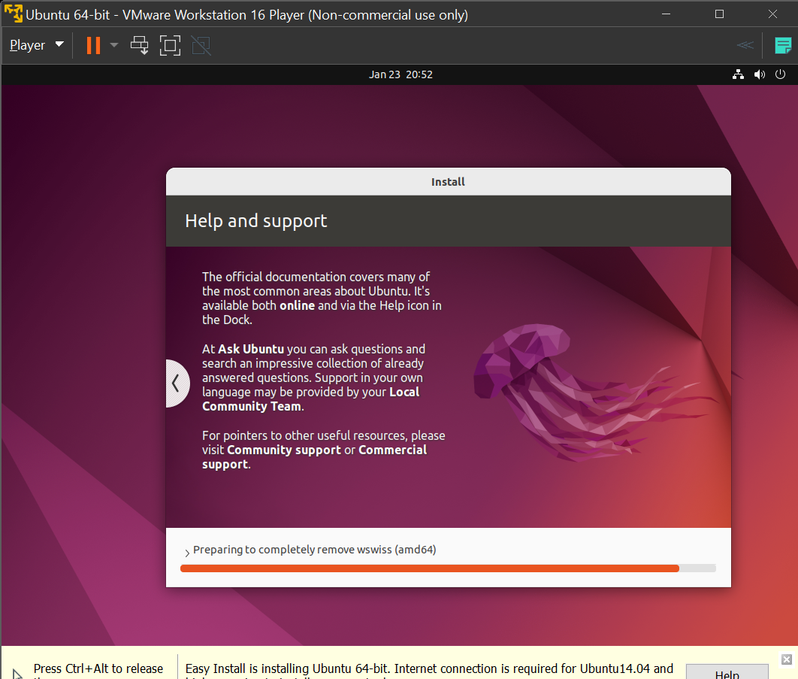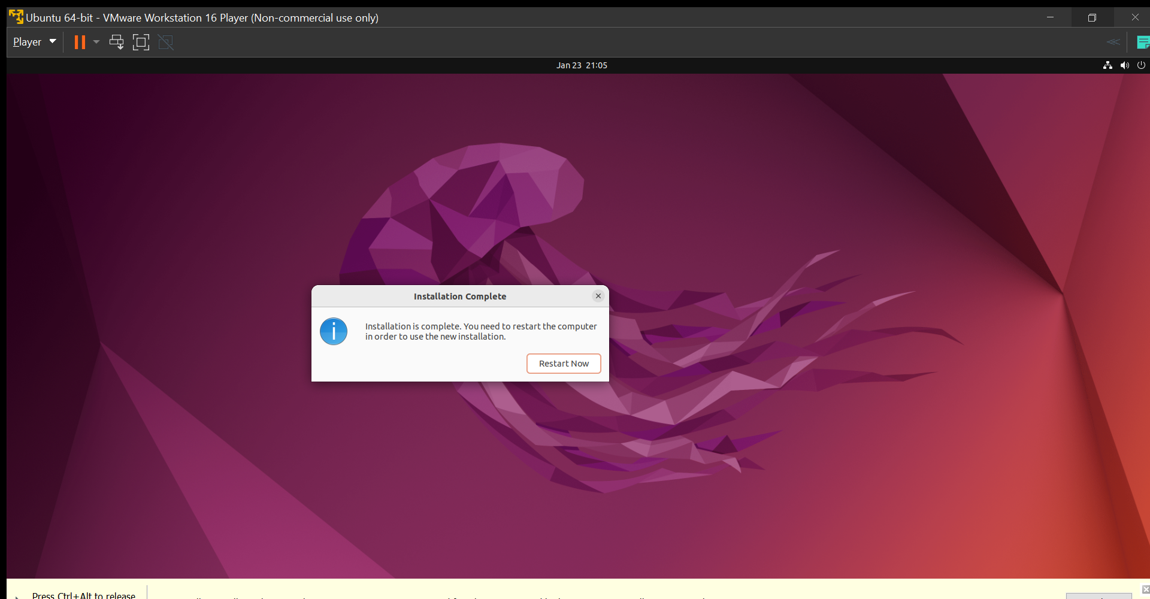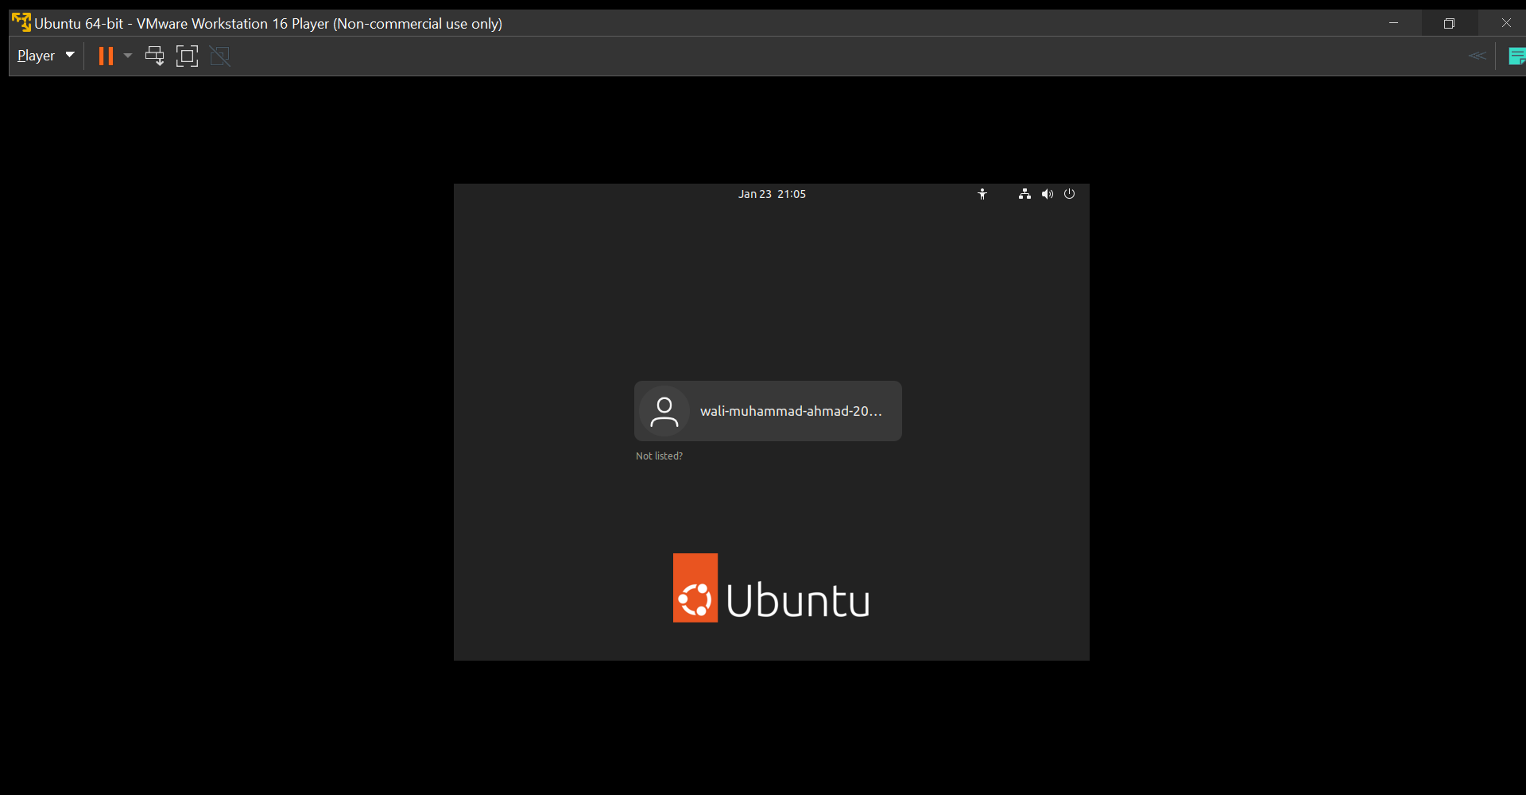

**Task 1 Reviews**

Task 1 was to Ubuntu in a Virtual Machine (VMware). I face 1 issue mention above that was solved and after that I face no issue and difficulty because I have done this before on both VirtualBox and VMware Player. So, it was quite easy for me this time.

**Task #2**

Task 2 was to install gcc and g++ compiler and execute c and c++ code on these compilers respectively. The method followed was given in the slides provided. It is shown below:

* **Installation of gcc**

Gcc Compiler was already installed on ubuntu 22.04 LTS. The code execution is show:

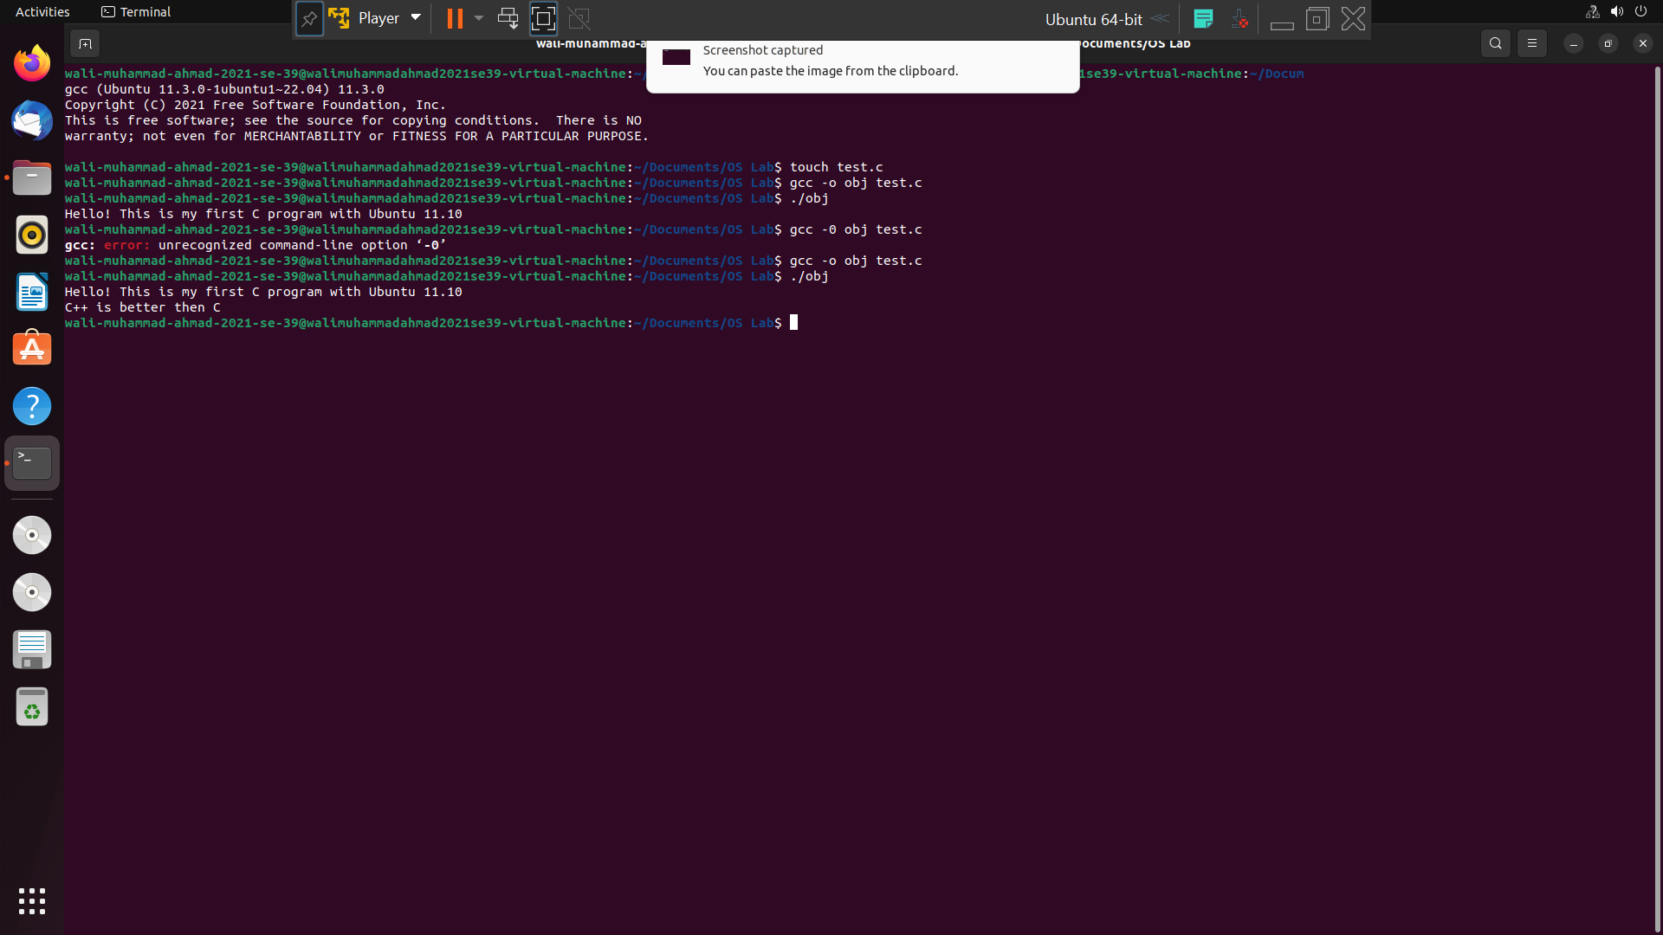

* **Installation of g++**

Gcc Compiler was installed by entering the command “sudo apt-get install g++” in terminal. The installation and execution is show below:

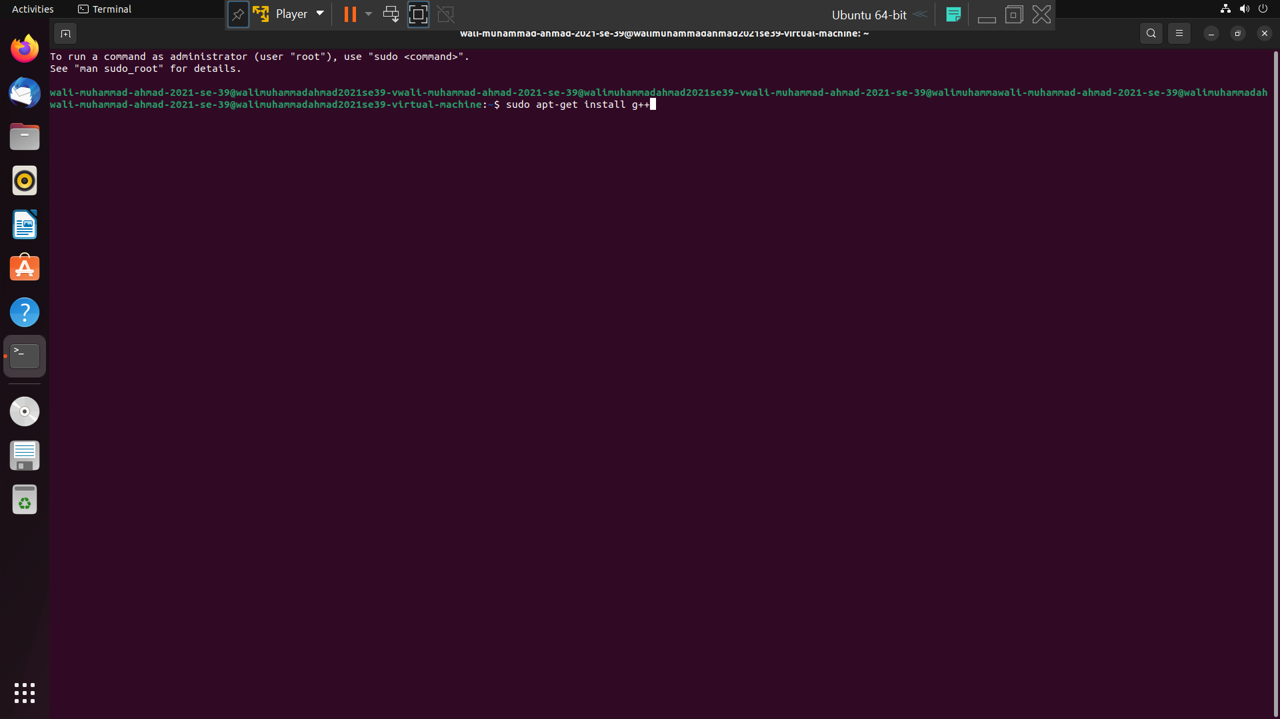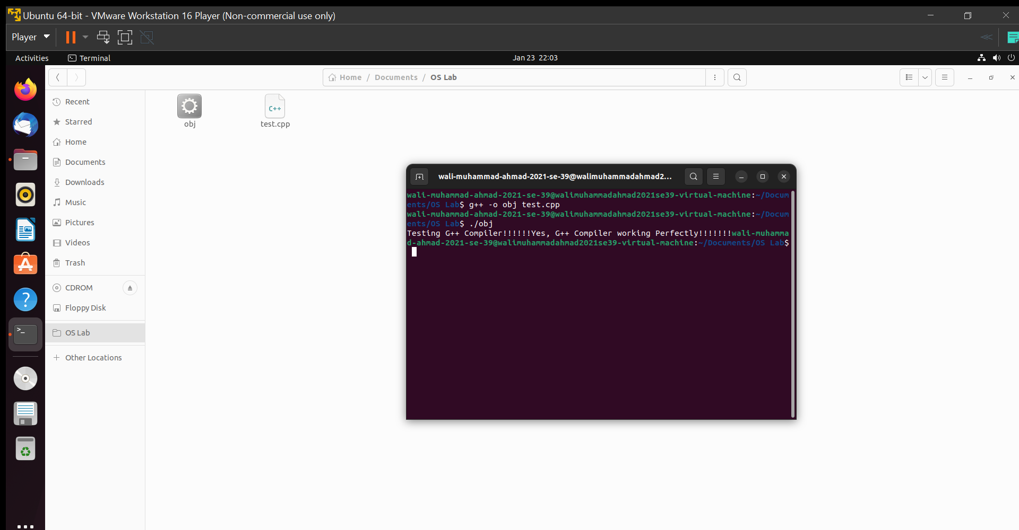**THE END**